Database Schema:

1. Users Table
- Table Name: users_user
- Description: Stores user information, including username, email, and role.
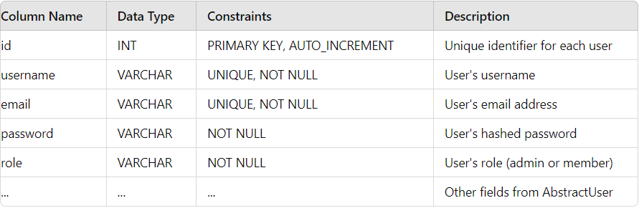
2. Projects Table
- Table Name: projects_project
- Description: Stores information about projects that users can create and manage.

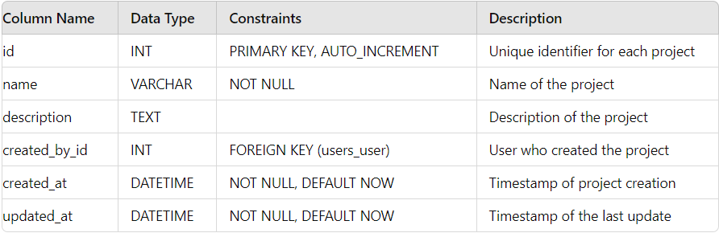

3. Tasks Table
- Table Name: tasks_task
- Description: Stores information about tasks within a project.

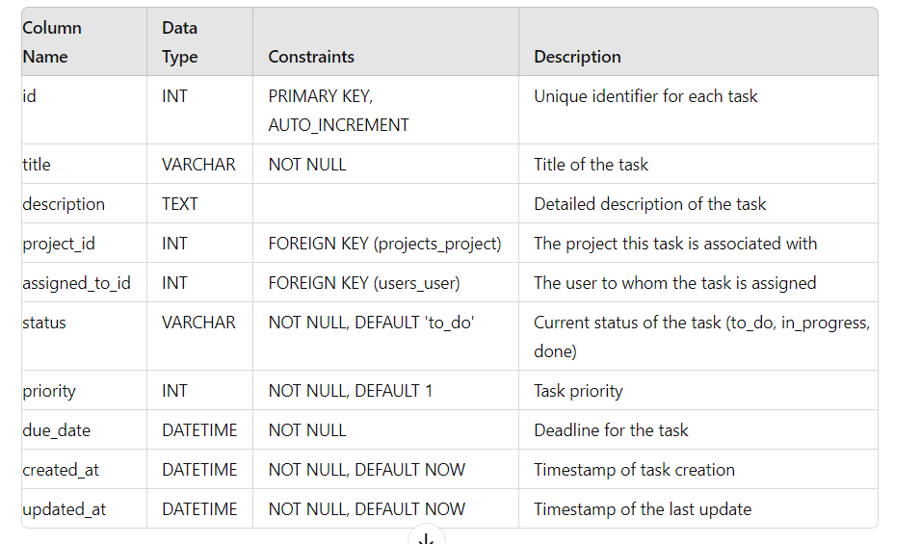
4. Comments Table
- Table Name: tasks_comment
- Description: Stores comments associated with tasks.
